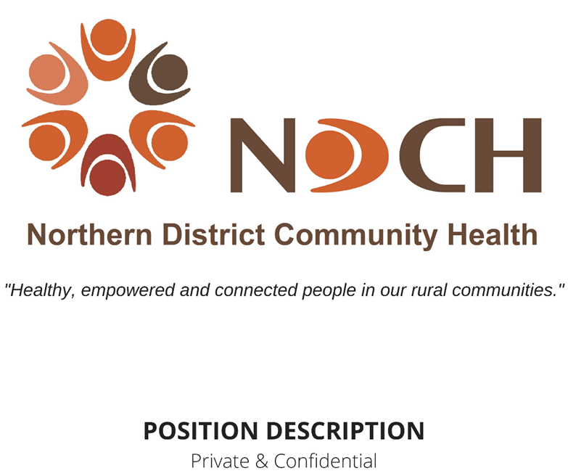

Position: | AOD & Generalist Counsellor
Staff Member: | VACANT
Location: | Based in Kerang, providing services across Gannawarra Shire, northern end of the Loddon Shire
Job Status: | Full Time  Position conditional on funding- 12 months, with the possibility of an ongoing role
Award: | SACS Award
Classification: | Level 4, Classification 2, Paypoint 3
Hours per fortnight: | 80 hours including ADO
Position Created: | March 2021
Last Review: | May 2022
Next Scheduled Review: | December 2022

Line of Management:
Reports To: Chief Executive Officer
GM – Program & Services
TL – Community Support
Supervises: NA
Internal Liaisons: GM – Corporate Services
Quality Governance Leader
Team Leaders
All NDCH Staff
Education, Qualifications & Experience:
- Appropriate academic qualifications in any of Counselling, Social Work or Welfare Studies.
- The Victorian Alcohol & Other Drugs sector’s minimum qualifications standard, requires the counsellor to have attained the four core competencies in AOD work. The service will support the counsellor to complete the competencies. Recognition of Prior Learning (RPL) is applicable
Key Selection Criteria:
- Past experience in providing counselling support to clients.
- Demonstrated interpersonal skills, strong verbal and written communication skills including ICT.
- Commitment to attaining the best outcomes for clients with alcohol and other drug issues
- Knowledge of, and commitment to, harm minimisation philosophy, community health policies, health promotion and early intervention
- Key knowledge of alcohol and other drug issues within the community
- Effective time management and organisational skills.
- Demonstrated ability to work independently and as a member of a multidisciplinary team and to work cooperatively and effectively within and across teams, as well as across services, to enhance client outcomes
- Well-developed organisational skills so as to be able to manage own time to achieve key outcomes and use tools effectively to assist with planning, organising and evaluation.
- The ability to communicate with tact and diplomacy to people of all ages is essential.
- Excellent communication skills – written (including ICT), verbal and presentation.
Purpose of this Position:
- To provide AOD and generalist counselling to individuals in the Gannawarra, Buloke and Northern Loddon Shires.
Responsibilities Specific to this Position:
- Provide comprehensive assessment and re-assessment of client need, as well as the setting of client goals for treatment.
- While the role predominantly focusses on generalist counselling services, provide some Alcohol and Other Drugs Counselling services in the contexts of both voluntary and mandated clients.
- To utilise knowledge and skills to work collaboratively with a client to facilitate insight, change and growth using a goal focussed approach.
- To utilise skills and knowledge required to support people of all ages dealing with a range of issues including life transitions and relationships, addiction, abuse, mental health, and many other areas of health and wellbeing.
- To actively support a healthcare team approach to the client’s care including GP.
- Support the most appropriate mode of delivery of service for the client, whether that is telehealth or face to face.
- Work within the Recovery Model of Care and Family Sensitive Practice.
- Be a participant of the Community Support Team intake.
- Be aware of current AOD referral pathways into the program, via ACSO, as well as support available post program.
- To refer those clients who can additionally or alternatively be best assisted by other services both within and outside NDCH.
- To promote healthy family relationships through education and community awareness.
- To inform and advise Management and your Team Leader on developments in the community counselling field relevant to the service.
- To maintain and submit statistical data in a timely manner and to prepare reports as requested.
Organisational Responsibilities:
- Keep accurate records of the program deliverables as set out in any funding agreement NDCH may hold with the funder and support the provision of this data in a timely fashion.
- Apply the NDCH risk management framework to all areas of your work, ensuring assessment of risk both within your clinical work and as an employee of NDCH is carried out to minimise as far as is practicable risks that arise.
- Apply the principles of working within a diverse workplace and with a diverse community, applying the fundamentals of the NDCH Diversity Policy, the Charter of Human Rights, and the United Nation’s Convention on the Rights of the Child.
- To always work within the NDCH culture, encouraging and supporting other staff to do so as well.
- To comply with NDCH Codes of Professional Conduct & Ethics.
- All qualified and Nationally Registered professionals are to respect and act in accordance with the laws of the jurisdictions in which they practice. Any professional bodies Codes of Conduct/Ethics/Standards should be interpreted with reference to these laws. The Codes/Standards should also be interpreted with reference to the organisational rules and procedures to which professionals may be subject. The code is not a substitute for requirements outlined in the National Law, other relevant legislation, or case law. Where there is any actual or perceived conflict between the code and any law, the law takes precedence.
- To actively participate, as part of an inter-disciplinary team, in a cooperative manner to enhance the team functioning including in Team Meetings.
- To work within a continuous quality improvement framework and support the agency’s quality review processes, including internal systems auditing.
- To participate in annual professional development, including review of position description.
- Be supportive of the broader NDCH team and encourage problem solving when issues arise within the culture of NDCH.
- Maintain a congenial, respectful working relationship with all colleagues as per the NDCH culture.
- If you disagree with Management on work-related policy, direction or activities, discuss your concern with your Team Leader in an appropriate setting.
- Contribute as a member of a multidisciplinary group to the success of your team
- Attend meetings and contribute to decision making and problem solving.
- Inform your Team Leader of emerging issues that relate to you and your teams role function, advising them of your management of caseloads and job tasks towards achieving program targets.
- Provide reports and documentation to Team Leaders as requested.
- To perform any other duties as delegated by Management or Team Leader as relevant to your position and scope of practice.
Health, Safety & Wellbeing:
- All NDCH staff have a responsibility to ensure their conduct and behaviour towards clients protects the client’s safety and wellbeing at all times.
- It is your duty to take reasonable care of the safety and health of yourself and other persons who may be affected by your acts or omissions in the work place.
- NDCH is an equal opportunity employer. NDCH is committed to employing people from diverse backgrounds and providing a workplace free from discrimination and harassment.
- All NDCH sites are smoke free workplaces.
- NDCH promotes respectful relationships and gender equality within the workplace and in our communities.
- NDCH has a culture of zero tolerance of violence, especially against vulnerable people, children and women, and takes an active role within the workplace and the community to promote this stance.
Mandatory Checks & Training:
COVID-19 Vaccination Status
NDCH is required, under the Victorian Government’s Mandatory Vaccination Directions, and as set out in NDCH Policy – Personnel COVID-19 Vaccination, to collect, record and hold current vaccination information about all personnel. These directions include not permitting any personnel who are unvaccinated and do not have an authorised exemption from COVID-19 vaccination onto the premises.
Drivers Licence
All staff are required to have and maintain a valid driver’s licence. Any conditions on your licence should be indicated in your application. Any change to the conditions of your driver’s licence whilst employed must be communicated to Management as soon as possible.
National Police Check:
Appointment and ongoing employment is subject to a satisfactory National Police Check. This is mandatory for all Employees.
All personnel of NDCH are required to notify Management as soon as possible of any criminal conviction.
International Police Check:
If the applicant has lived overseas for twelve (12) months or more in the last ten (10) years, an International Police Check will be required before commencing in this role.
All staff are required to sign a statutory declaration in regards to ever having, since the age of 16 years, been a citizen or resident of any countries other than Australia and been convicted of murder or sexual assault or convicted of and sentenced to imprisonment for any form of assault.
Working with Children Check (WWCC):
It is a requirement of NDCH that all employees undergo a Working with Children Check in accordance with the Working with Children Act 2005 (amended 2016).
Child Safe Standards Training
All staff are required to undertake the Child Safe online module with the Centre for Excellence in Child and Family Welfare to gain the knowledge and skills necessary to embed the child safe standards into their practice. This will be undertaken after commencement in your role with update opportunities made available.
Family Violence Training
NDCH provides training opportunities for staff under the Strengthening Hospital Responses to Family Violence and, for those staff who work 1:1 with clients, Child (CISS) and Family Violence Information Sharing (FVISS) Schemes.
All staff of NDCH are required to complete (or have completed) all training in family violence as relevant and appropriate to their role and to work within the scope of the Family Violence and Child Information Sharing Schemes as legislated in Victoria.
NDIS
For those staff providing NDIS supports:
Victoria has a ‘no clearance, no start’ approach to the NDIS Check. This means that a person is prohibited from being employed or otherwise engaged by a registered NDIS provider like NDCH in a risk assessed role unless the person has an NDIS Clearance or is “subject to a transitional arrangement”.
Those staff working in specific disability services (NDIS) are required to undertake any training to understand and meet their obligations under the NDIS Practice Standards and other NDIS rules.
For all staff:
All staff working for an organisation such as NDCH that provides disability services are required to sign their commitment to work within the NDIS Quality & Safeguards Commission Code of Ethics, even if their role does not require them to provide specific disability supports.
Signed in Acknowledgement:
Employee: |  | / /20
Manager: |  | / /20

