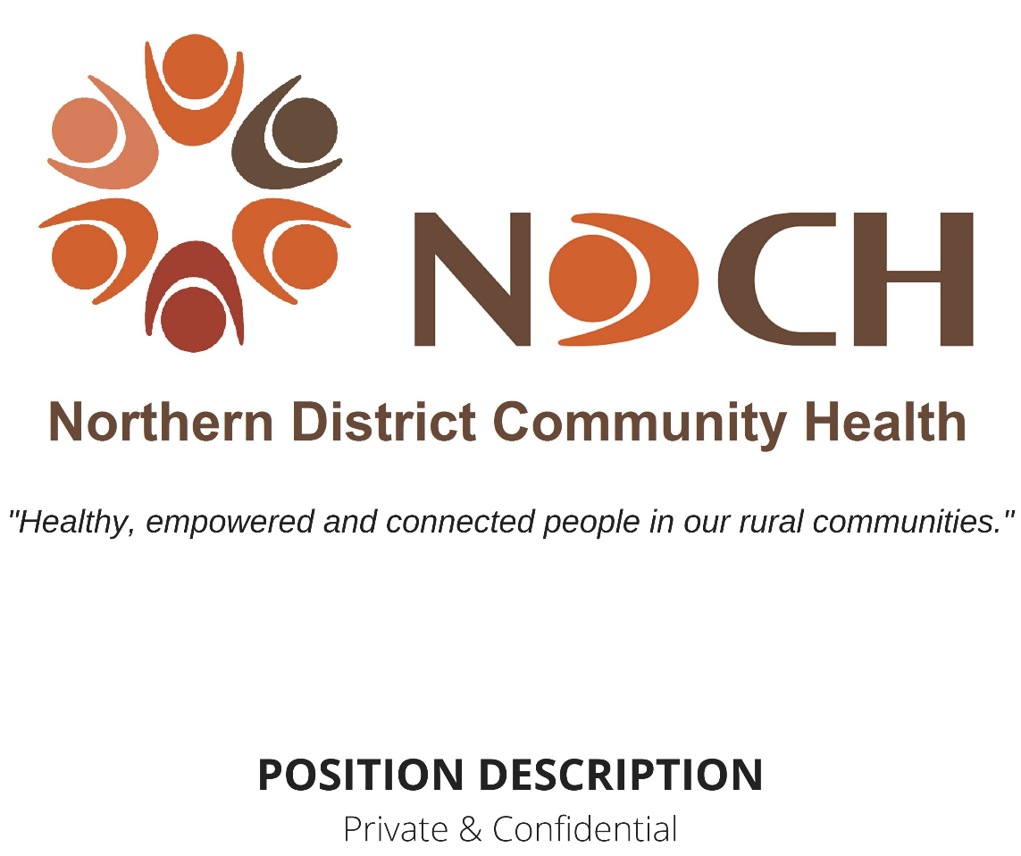

Position: | Allied Health, Dietitian
Staff Member:
Location: | Based in Kerang, providing services across Gannawarra Shire, northern end of Loddon Shire.  NDCH Policy – Working from Home may be applicable to this position.
Job Status: | Full Time Maternity Leave Position  Position conditional on funding
Award: | Medical Scientists
Classification: | Dietitian Grade 2
Hours per fortnight: | 80 hours including ADO
Position Created: | July 2002
Last Review: | April 2023
Next Scheduled Review: | April 2024

Line of Management:
Reports To: Chief Executive Officer
GM – Program & Services
Allied Health Team Leader
Supervises: N/A
Internal Liaisons: GM – Corporate Services
Quality Governance Leader
Team Leaders
All NDCH Staff
Education, Qualifications & Experience:

- Bachelor of Nutrition and Dietetics or equivalent.
- Member of Dietitians Association of Australia (DAA) with Accredited Practising Dietitian (APD) Status or eligible to apply for APD status.
Key Selection Criteria:
- Experience to enable a complete general Dietetic service to be offered to a rural community.
- Past experience working with both groups and individuals.
- Must be able to work within a multi-disciplinary setting and communicate effectively with professionals both within and outside NDCH both verbally and in writing.
- To have well developed organisational and communication skills.
- Knowledge of issues/culture of a rural community.
- A demonstrated understanding and commitment to the concept of health promotion, community development and community health.
- A current drivers licence
Purpose of this Position:
- To provide effective and appropriate nutritional information and support in one on one and group scenarios in a community health setting. Includes some contracted work to local residential services and NDIS participants.
Responsibilities Specific to this Position:
- To assess the needs of presenting clients in an evidence based approach.
- To work within the philosophies of community health and early intervention.
- To assist with facilitating, developing and operating a community health program which reflects the community’s needs.
- To promote good health and wellbeing in the communities covered by NDCH.
- To actively participate as part of a multi-disciplinary team.
- To contribute to a team environment amongst the staff at NDCH, which is commensurate with providing high quality health care for the community.
- Maintain up to date nutrition resources.
- Maintain close liaison with other dietitians, service staff, community groups and other agencies.
- Provide consultancy advice to all service staff about all aspects of nutrition.
- To undertake and participate with others in health promotion and education including group and community liaison programs. Health Promotion will be an integral component of all activities.
- Assist the broader team of NDCH with planning nutrition programs and services for the community.
- Plan, promote and provide the service’s health promotion and early detection programs in conjunction with other staff.
Organisational Responsibilities:
- Keep accurate records of the program deliverables as set out in any funding agreement NDCH may hold with the funder and support the provision of this data in a timely fashion.
- Apply the NDCH risk management framework to all areas of your work, ensuring assessment of risk both within your clinical work and as an employee of NDCH is carried out to minimise as far as is practicable risks that arise.
- Apply the principles of working within a diverse workplace and with a diverse community, applying the fundamentals of the NDCH Diversity Policy, the Charter of Human Rights, and the United Nation’s Convention on the Rights of the Child.
- To always work within the NDCH culture, encouraging and supporting other staff to do so as well.
- To comply with NDCH Codes of Professional Conduct & Ethics.
- All qualified and Nationally Registered professionals are to respect and act in accordance with the laws of the jurisdictions in which they practice. Any professional bodies Codes of Conduct/Ethics/Standards should be interpreted with reference to these laws. The Codes/Standards should also be interpreted with reference to the organisational rules and procedures to which professionals may be subject. The code is not a substitute for requirements outlined in the National Law, other relevant legislation, or case law. Where there is any actual or perceived conflict between the code and any law, the law takes precedence.
- To actively participate, as part of an inter-disciplinary team, in a cooperative manner to enhance the team functioning including in Team Meetings.
- To work within a continuous quality improvement framework and support the agency’s quality review processes, including internal systems auditing.
- To participate in annual professional development, including review of position description.
- In keeping with the principles of the Victorian Government’s Child Safe Standards, embed within NDCH an organisational culture of child safety through effective leadership, and to always perform duties of this role within those standards.
- To be knowledgeable of and work within the suite of policies and procedures of NDCH, as well as NDCH’s vision, mission and values.
- Be supportive of the broader NDCH team and encourage problem solving when issues arise within the culture of NDCH.
- Maintain a congenial, respectful working relationship with all colleagues as per the NDCH culture.
- If you disagree with Management on work-related policy, direction or activities, discuss your concern with your Team Leader in an appropriate setting.
- Contribute as a member of a multidisciplinary group to the success of your team
- Attend meetings and contribute to decision making and problem solving.
- Inform your Team Leader of emerging issues that relate to you and your teams role function, advising them of your management of caseloads and job tasks towards achieving program targets.
- Provide reports and documentation to Team Leaders as requested.
- To perform any other duties as delegated by Management or Team Leader as relevant to your position and scope of practice.
Health, Safety & Wellbeing:
- All NDCH staff have a responsibility to ensure their conduct and behaviour towards clients protects the client’s safety and wellbeing at all times.
- It is your duty to take reasonable care of the safety and health of yourself and other persons who may be affected by your acts or omissions in the work place.
- NDCH is an equal opportunity employer. NDCH is committed to employing people from diverse backgrounds and providing a workplace free from discrimination and harassment.
- All NDCH sites are smoke free workplaces.
- NDCH promotes respectful relationships and gender equality within the workplace and in our communities.
- NDCH has a culture of zero tolerance of violence, especially against vulnerable people, children and women, and takes an active role within the workplace and the community to promote this stance.
Mandatory Information, Checks & Training:
COVID-19 Vaccination Status
NDCH is required, under the Victorian Government’s Mandatory Vaccination Directions, and as set out in NDCH Policy – Personnel COVID-19 Vaccination, to collect, record and hold current vaccination information about all personnel. These directions include not permitting any personnel who are unvaccinated and do not have an authorised exemption from COVID-19 vaccination onto the premises.
Drivers Licence
All staff are required to have and maintain a valid driver’s licence. Any conditions on your licence should be indicated in your application. Any change to the conditions of your driver’s licence whilst employed must be communicated to Management as soon as possible.
National Police Check:
Appointment and ongoing employment is subject to a satisfactory National Police Check. This is mandatory for all Employees.
All personnel of NDCH are required to notify Management as soon as possible of any criminal conviction.
International Police Check:
If the applicant has lived overseas for twelve (12) months or more in the last ten (10) years, an International Police Check will be required before commencing in this role.
All staff are required to sign a statutory declaration in regards to ever having, since the age of 16 years, been a citizen or resident of any countries other than Australia and been convicted of murder or sexual assault or convicted of and sentenced to imprisonment for any form of assault.
Working with Children Check (WWCC):
It is a requirement of NDCH that all employees undergo a Working with Children Check in accordance with the Working with Children Act 2005 (amended 2016).
Child Safe Standards Training
All staff are required to undertake the Child Safe online module with the Centre for Excellence in Child and Family Welfare to gain the knowledge and skills necessary to embed the child safe standards into their practice. This will be undertaken after commencement in your role with update opportunities made available.
Family Violence Training
NDCH provides training opportunities for staff under the Strengthening Hospital Responses to Family Violence and, for those staff who work 1:1 with clients, Child (CISS) and Family Violence Information Sharing (FVISS) Schemes.
All staff of NDCH are required to complete (or have completed) all training in family violence as relevant and appropriate to their role and to work within the scope of the Family Violence and Child Information Sharing Schemes as legislated in Victoria.
NDIS
For those staff providing NDIS supports:
Victoria has a ‘no clearance, no start’ approach to the NDIS Check. This means that a person is prohibited from being employed or otherwise engaged by a registered NDIS provider like NDCH in a risk assessed role unless the person has an NDIS Clearance or is “subject to a transitional arrangement”.
Those staff working in specific disability services (NDIS) are required to undertake any training to understand and meet their obligations under the NDIS Practice Standards and other NDIS rules.
For all staff:
All staff working for an organisation such as NDCH that provides disability services are required to sign their commitment to work within the NDIS Quality & Safeguards Commission Code of Ethics, even if their role does not require them to provide specific disability supports.
Signed in Acknowledgement:
Employee: |  | / /20
Manager: |  | / /2022

